Final Project – Jo De Leon

DAD-220-J1269

**Task One**

Explanation: *This statement adds new data in the table by inserting a new record using “Insert into table” with new values in each column as indicated in the statement following the datatypes set per column.*

**Task Two**

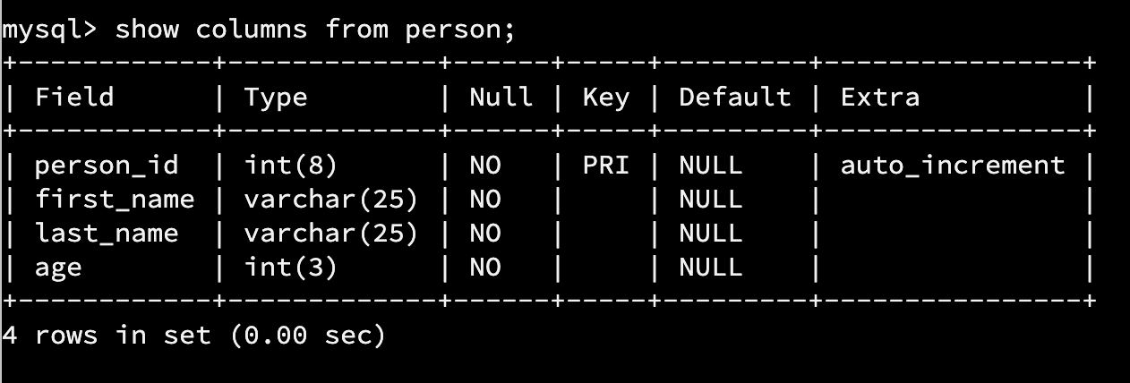

Explanation: *This statement alters a table by using “Alter table”. In this particular change, we added a new column with a datatype of int(3) with a constraint of “Not Null” – meaning that the column must not be empty.*

**Task Three**

Explanation: *This statement updates an existing record in a table by using “Update” and “Set” and is used with a constraint. Without a constraint, the update will be applied to all records in the table for the given column.*

**Task Four**

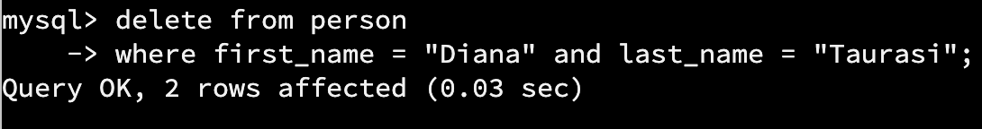

Explanation: *This statement deletes row(s) of record(s) in a table with a condition/constraint.*

*Note: The records in the table were duplicated when I set up the tables prior to doing the tasks. I deleted the duplicated records.*

**Task Five**

Explanation: *This statement alters a table by using “Alter table”. In this particular change, we added a new column with a datatype of varchar(10) and may be empty since it is not required using “default NULL”.*

**Task Six**

Explanation: *This statement updates an existing record in a table by using “Update” and “Set” and is used with a constraint. Without a constraint, the update will be applied to all records in the table for the given column.*

**Task Seven**

Explanation: *This statement updates an existing record in a table by using “Update” and “Set” and is used with a constraint. Without a constraint, the update will be applied to all records in the table for the given column.*

**Task Eight**

Explanation: *This statement adds new data in the table by inserting a new record using “Insert into table” with new values in each column as indicated in the statement following the datatypes set per column.*

**Task Nine**

Explanation: *This statement creates a new table in a database by using “Create”. The columns details are set by indicating the column title, datatype, and any constraints it may/should have. A column may also be set as a primary key and may be auto_incremented.*

**Task Ten**

Explanation: *This statement creates a new table in a database by using “Create”. The columns details are set by indicating the column title, datatype, and any constraints it may/should have. A column may also be set as a primary key and may be auto_incremented.*

**Task Eleven**

Explanation: *This statement adds new data in the table by inserting a new record using “Insert into table” with new values in each column as indicated in the statement following the datatypes set per column.*

**Task Twelve**

Explanation: *This statement adds new data in the table by inserting a new record using “Insert into table” with new values in each column as indicated in the statement following the datatypes set per column.*

**Task Thirteen**

***select s.first_name as "Sender's first name", s.last_name as "Sender's last name", r.first_name as "Receiver's first name", r.last_name as "Receiver's last name", m.message_id as "Message ID", m.message as "Message", m.send_datetime as "Message Timestamp"***

***-> from person s, person r, message m***

***-> where s.person_id = m.sender_id and r.person_id = m.receiver_id and s.first_name = "Michael" and s.last_name = "Phelps";***

Explanation: *This statement outputs data using “Select” based on the conditions set by using “Where”. “As” is used to rename the column for the output of data from multiple tables.*

**Task Fourteen**

***select count(message.message_id) as 'Count of messages', person.person_id as 'Person ID', person.first_name as 'First Name', person.last_name as 'Last Name'***

***-> from message, person***

***-> where message.sender_id = person.person_id***

***-> group by person.person_id;***

Explanation: *This statement outputs data using “Select” based on the conditions set by using “Where”. “As” is used to rename the column for the output of data from multiple tables. “Count” is used to count the total number of messages sent by a person. “Group by” is used to ensure that the statement counts the data per row and not just one..*

**Task Fifteen**

***select message.message_id as 'Message ID', message.message as 'Message', message.send_datetime as 'Message Timestamp', image.image_name as 'First Image Name', image.image_location a***

***s 'First Image Location'***

***-> from message***

***-> inner join message_image***

***-> on message.message_id = message_image.message_id***

***-> inner join image***

***-> on image.image_id = message_image.image_id***

***-> group by message_image.message_id;***

Explanation: *This statement outputs data using “Select” based on the conditions set by using “Where”. “As” is used to rename the column for the output of data from multiple tables. “Inner join” is used to join columns from multiple tables together.*